Matrix Chain Multiplication

Problem
We are given n matrices, we have to multiply them in such a way that the total number of operations are minimum.

Example
[]_{1x2} []_{2x3} []_{3x4}
A B C

Since we know multiplication of matrices is associative, hence
A(BC) = (AB)C

Operations in A(BC)
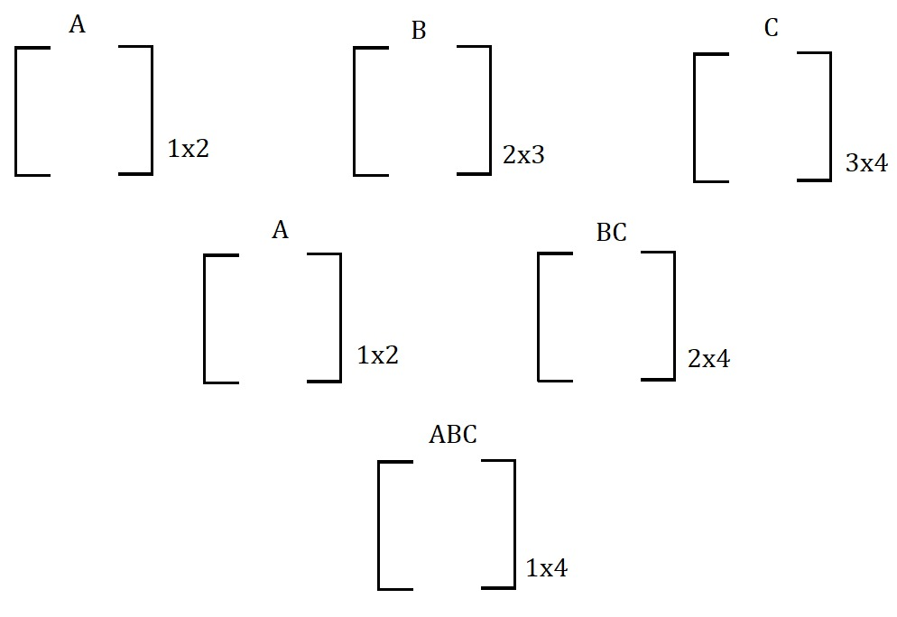

(Total operations)_{A(BC)} = 2x3x4 + 1x2x4 = 32 operations

Operations in (AB)C
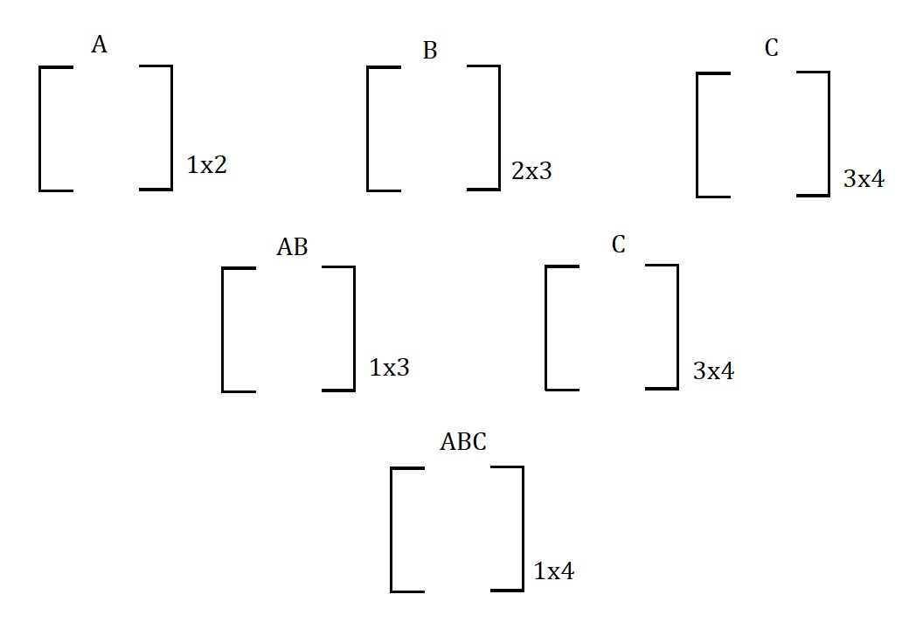
(Total Operations)_{A(BC)} = 1X2X3 + 1X3X4 = 18 operations

Therefore, (AB)C is more efficient than A(BC).

Dimensions of matrices will be given in the form of an array.

Example
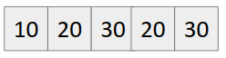
The Dimension of i^{th} matrix is a[i-1] x a[i].
Example
M₁ -> a[0] x a[1] = 10 x 20
M₂ -> a[1] x a[2] = 20 x 30
M₃ -> a[2] x a[3] = 30 x 20
M₄ -> a[3] x a[4] = 20 x 30

Therefore dimension of matrix multiplication from
M_{i} to M_{j} -> a[i-1] x a[j]
Example: M₁ M₂ M₃ -> a[0] x a[3] = 10 x 20

Our Recurrence Relation becomes
f(M₁M₂....M_{N}) = min(f(M₁....M_{k}) + f(M_{k+1}....M_{N}) + a[0] x a[1] x a[N] )
where 1<= k <= N-1

Let us take 4 matrices A, B, C, D.

We can see that answer of ABCD depends on
- (A)(BCD)
- (AB)(CD)
- (ABC)(D)

Whichever from 1. , 2. Or 3 gives minimum operations, that is the answer.

In other words, we can say that 3 cuts are possible,
(i) A | B C D
(ii) A B | C D
(iii) A B C | D

We can write its recurrence as
f(ABCD) = min(f(A|BCD), f(AB|CD), f(ABC|D))
Since it has a recurrence relation, therefore it follows optimal substructure property.

Checking whether it has overlapping subproblem property also?

Making recursion tree
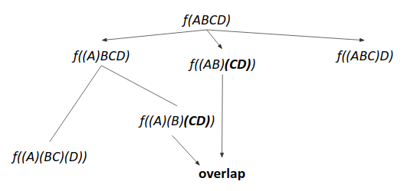

We can see that computation of f(CD) is repeated, hence it possesses overlapping subproblem property.

Hence it can be solved using dynamic programming.

Approach 1
- Write the recursive solution.
- Memoize it.

Approach 2 (Tabulation (Bottom Up))
- Build from base.
- For each gap=0 to gap=n-2, compute all submatrix multiplication and their results.
- Build the answer using,
for every k=i to k=j-1
dp[i][j] = min(dp[i][j], dp[i][k] + dp[k+1][j] + a[i-1] x a[k] x a[j])

Time complexity: O(n³)

Code (Recursive)
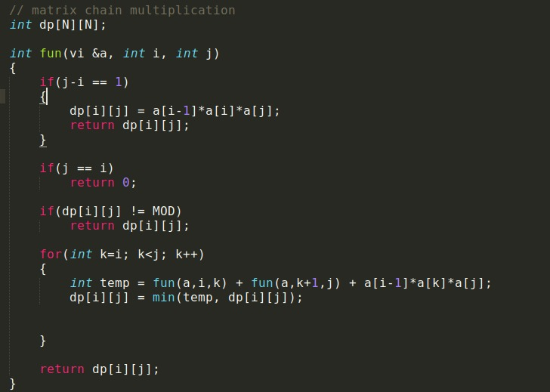
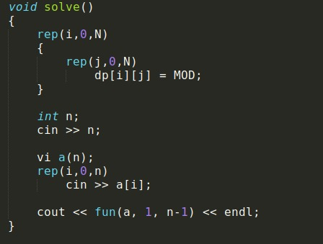

Code (Iterative)
